This is to inform you that all project teams must use Jira (Kanban) for continuous tracking of feature development throughout the semester.
Instructions
- After receiving final approval of your project idea and functional requirements, you must:
  - Create a Kanban project in Jira
  - Break down your project into appropriate tasks (functional requirements, bugs, improvements, etc.).
  - Maintain continuous updates as development progresses
- Team & Faculty Access (Mandatory):
  - Add all team members to the Jira project
  - Add both lab faculties as project members
- Evaluation & Monitoring - Your Jira board will be used to evaluate:
  - Feature-wise progress
  - Task ownership and collaboration
  - Consistency of development activities
  - Proper use of Kanban workflow
- Failure to create and maintain the Jira Kanban project properly may negatively impact your project evaluation. Please ensure compliance immediately after project approval. For any clarification, consult your lab faculty.

Manual:
- Each team will create a new project in Jira (Atlassian).
- Choose Kanban for the project template.
- Choose Team-managed for the project type.
- Add other team members to your project. Also, add your project supervisors (Lab faculty) to your project.
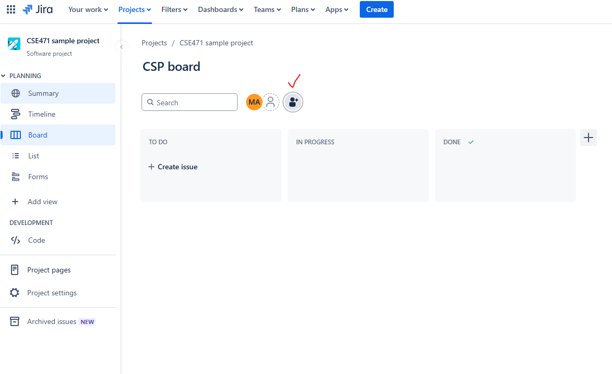
- Add all the functional requirements in the to-do board.
- Assign group members to different tasks.
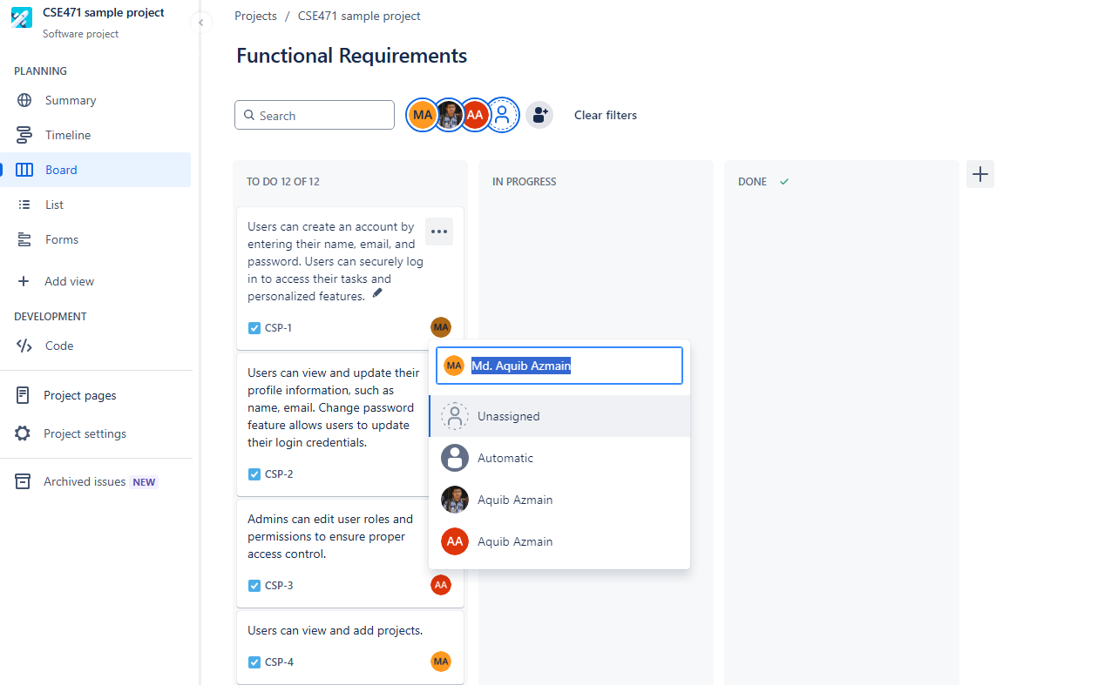
- For every module, 4 tasks will be shifted to “In Progress”. Each member has to demonstrate at least one feature in every module.

